What is a Theory of Change?

“A theory of change is a theory or hypothesis that describes the root cause of the problem, desired outcome(s) and how to reach those outcome(s)” (JBS International, Inc. on behalf of the Children’s Bureau: Implementation Tool Kit). The theory of change provides a road map that addresses how and why change will happen in a practice, program or organizational system to promote the attainment of a desired result. Essentially the theory explains why the change that is being proposed should work by explaining how the steps being taken should lead to intended results.
The theory of change should be based on research. To avoid theories based on assumptions, it is important to consider available theories and existing research evidence. In the case of the QIC-AG, research may include findings from the population template, the continuum assessment and the white papers. Research may also include findings from site-based research projects that preceded QIC-AG participation but are relevant to the target population and problem being addressed. Other examples of existing research evidence include peer-reviewed articles and other less rigorously reviewed child-welfare products/publications. The research should be used to support the pathway to change that is being proposed.
A well-crafted theory of change serves many purposes. Most importantly, the theory of change will serve as a guide for identifying the intervention that will be implemented.

How does a Theory of Change Differ from a Logic Model?

There is often confusion about the difference between a theory of change and a logic model. Unlike a logic model, the theory of change does not necessitate the identification of a specific intervention. A theory of change is typically one component of a logic model. A theory of change is more theoretical than a logic model, which is more concrete in its purpose. The theory of change identifies the pathway of change from the root cause to the desired outcomes, while the logic model identifies the components of an intervention, inputs, outputs and expected outcomes.

Developing a Theory of Change

Step One: Determining the Root Cause
Developing a theory of change starts with understanding the problem that needs to be addressed as well as the root cause of the problem, often referred to as an underlying or fundamental factor that causes a problem. For our purposes, it may be beneficial to think about a root cause as follows: “The most basic cause (or causes) that can reasonably be identified that management has control to fix and, when fixed, will prevent (or significantly reduce the likelihood of) the problem’s recurrence” (Paradies, 2005).
A straightforward way of getting to the root cause is the “why” method. To facilitate the process, one should start with a problem statement and then ask five “why” questions that help drill deeper, peeling away layers of symptoms, until the issue that is causing the problem is uncovered. Each “why” question will lead to the next “why” question. Asking approximately five questions is a good rule of thumb, but sometimes you may need to ask and answer more or fewer questions to get to the root cause. Your problem statement and “why” answers should be guided by both your interval on the continuum as well as information already gathered during the exploration phase through the population template and the continuum assessment.

The following is a silly example of the “why” method of determining a root cause, but one that will help elucidate the process (http://www.isixsigma.com/tools-templates/cause-effect/determine-root-cause-5-whys/):
Problem Statement: You are on your way home from work and your car stops in the middle of the road.

- Why did your car stop?
- Because it ran out of gas.

- Why did it run out of gas?
- Because I didn’t buy any gas on my way to work.

- Why didn’t you buy any gas this morning?
- Because I didn’t have any money.

- Why didn’t you have any money?
- Because I lost it all last night in a poker game.

- Why did you lose your money in last night’s poker game?
- Because I’m not very good at “bluffing” when I don’t have a good hand.

Another example of the “why” method that applies to QIC-AG in the focused interval is as follows:

Problem Statement: Children with emotional, mental health and behavioral issues are in pre-adoptive homes, but the permanencies are not finalizing.

- Why are families not finalizing adoptions or guardianships?
- Because they don’t feel emotionally or practically competent/confident to meet the needs of the child.

- Why don’t families feel emotionally and practically confident to meet the needs of the child?
- Because the foster care system is not giving them the tools they need to feel prepared to assume the role of adoptive parent or guardian.

- Why is the foster care system not preparing families to assume the role of adoptive parent or
guardian?
- Because there is a lack of programming designed to prepare families for permanence.

- Why is there a lack of programming designed to prepare families for permanence?
- Because there are limited resources available for this population.

- Why are there limited resources for programs designed to prepare families for permanence?
- Because it is not a priority for the site.

Step Two: Creating the Steps

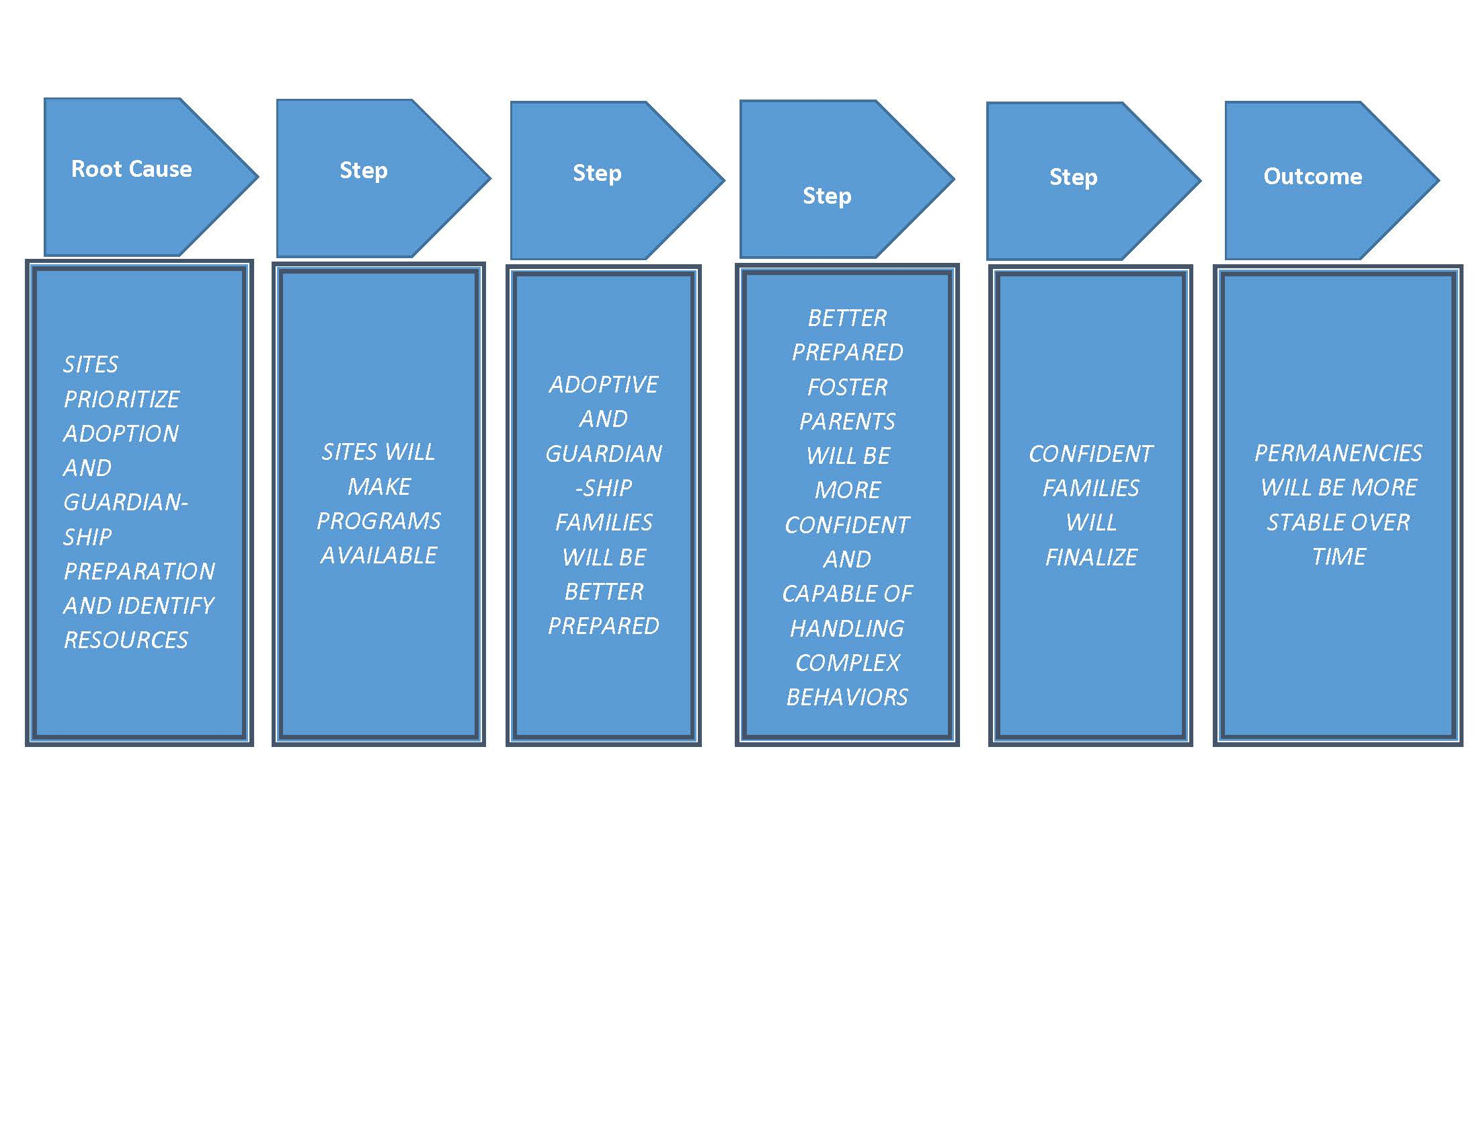
Once you have identified your root cause, you will then identify the steps that will be used to take you from your root cause to your intended outcome. You can think about the steps as a series of if-then statements that represent the causal links between each element so that each step moves you toward your desired outcome. The desired long-term outcomes for all QIC-AG interventions are: 1) increased post-permanency; 2) improved child well-being; and 3) improved behavioral health for children and youth.

Step Three: Expanding the Steps

Once the steps have been delineated, the theory of change can be written in paragraph form. During this process, the steps can be expanded to include detail to support the logic. For example, it may be prudent to note the type of preparation that will be provided to improve confidence and competence of the caregiver. The expanded version of the theory of change is as follows:
Caregivers are not finalizing adoptions and guardianship because there are insufficient programs to support this transition. This is especially true for caregivers of children with emotional, behavioral or mental-health issues. If making such programs available becomes a priority as evidenced by the allocation of agency resources, then a significant barrier to permanency can be addressed. Families will be able to take advantage of preparation classes to improve both their confidence and capabilities related to handling complex behavioral, emotional and mental-health issues. Preparation classes will provide a deeper level of understanding of the children and youth’s emotional-behavioral .issues as well as concrete skills to manage the behaviors.

Once prospective adoptive parents have participated in the preparation program, they will feel more confident and capable of addressing complex behaviors. Caregivers who are provided the preparation will, in turn, be more likely to finalize the permanencies and have a greater capacity to sustain stable permanencies.

Step Four: Testing the Theory of Change

Once the theory of change is written, there is still a little more work to be done to ensure the quality of the theory. Quite simply, it is important to make sure that the theory makes sense. This can be done by asking a series of questions that were developed by JBS International, Inc. on behalf of the Children’s Bureau: Implementation Tool Kit:
Plausibility: Does the logic of the pathway seem correct? If we follow the if-then statements, will we get to the outcomes that we desire? What end results do we expect to see?
Testability: Are there credible ways to measure whether progress is happening?
Significance: Are the desired outcomes important? Is the magnitude of change worth the effort?
Alignment: Are the designed outcomes aligned with the agency’s values, vision and philosophy?

It is important to remember that a theory of change may be altered as the thinking about the problem becomes clearer.]

